It’s time to start preparing for the 2016 AgrAbility National Training Workshop (NTW)! The NTW will be held in Fort Collins, Colorado April 11-14. In previous years, our conference has been attended by up to 250 people representing 38 states, more than 50 of whom were farmers on scholarship. Additionally, we have had representatives from Canada, Sweden, Finland, and Brazil in attendance. These numbers represent records for the conference that we expect to continue to rise.

I would like to invite you to join us this year. We have set the exhibitor rate at $150 for commercial exhibitors and $100 for non-profit exhibitors for one tabletop plus registration for your representative(s). The registration fee will be $400 for early registration (register before 3/11/16) or $450 for late registration. You can find more information on the conference website, http://agrability.org/ntw/.

Being an exhibitor at the 2016 NTW will also allow you a short block of time in the Assistive Technology (AT) Show and Tell session if you would like to talk about your products and give demonstrations or show videos of demonstrations.

We are also offering businesses the opportunity to be a sponsor of our event. Sponsorship would allow your company a complementary booth space and would also waive the registration fee for one representative. The minimum amount to reach this level is a donation of $900. Please see the attached sponsorship letter which details information on sponsorship levels and options.

Thank you for your time and consideration. Please do not hesitate to contact me with any questions at the number listed below or by email. Thanks again and I hope to see in Fort Collins this spring!

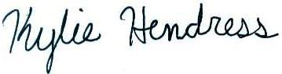

Kylie Hendress
Engagement Coordinator
National AgrAbility Project
Purdue University
225 S University Street
West Lafayette, IN 47907
765-425-3914
www.agrability.org
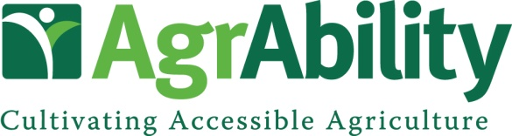

National Training Workshop
Fort Collins, CO April 11-14, 2016

Exhibitor Contact Information

Company Name:
Contact:
Address:
City:
State/Province: Zip Code:
Phone: Fax:
Email: Website:
Exhibitor Type (circle one): Commercial Non-Profit AgrAbility Do you need electricity? Yes No
Are you interested in helping sponsor this event? Please see the benefits of sponsorship below and let us know if you would like to take advantage of this opportunity. Thank you!

Benefits to Sponsor

- Complementary booth space at the NTW trade show (for sponsorships of $900 and up)
- Complementary registration for one company representative (for sponsorships of $900 and up)
- Signage and verbal recognition throughout the National Training Workshop
- Company name and logo on NTW schedules and programs
- Company logo displayed on the AgrAbility NTW website with a link to the company’s website
- Company listed as a sponsor on promotional materials which will be distributed nationwide

Suggested Sponsorship Opportunities

Bronze Level: Under $1,100
Hospitality Room: $900
Pre-Conference Tour: $1,000
Morning Break: $1,100

Silver Level: $1,101-$3,000
Speaker Gifts: $1,750
Afternoon Break: $2,500
Promotional Giveaways: $3,000
Gold Level: $3,001-$5,000
Conference Tour: $3,100
Breakfast: $3,500
Keynote Speaker: $4,000

Platinum Level: Over $5,000
Welcome Reception: $5,000
Lunch: $5,500
Banquet/Benefit Auction: $10,000

We would be glad to discuss other options to customize your sponsorship. Please call or email. All donations are tax deductible and are administered by the National AgrAbility Project at Purdue University. Checks should be made payable to Purdue University. Mail to Breaking New Ground Resource Center, Purdue University, 225 South University St, West Lafayette, IN 47907.

